**Tugas - Tree**

Nama : Rizqi Rohmatul Huda

Kelas : 2G – TI

No.Absen : 26

NIM : 2141720264

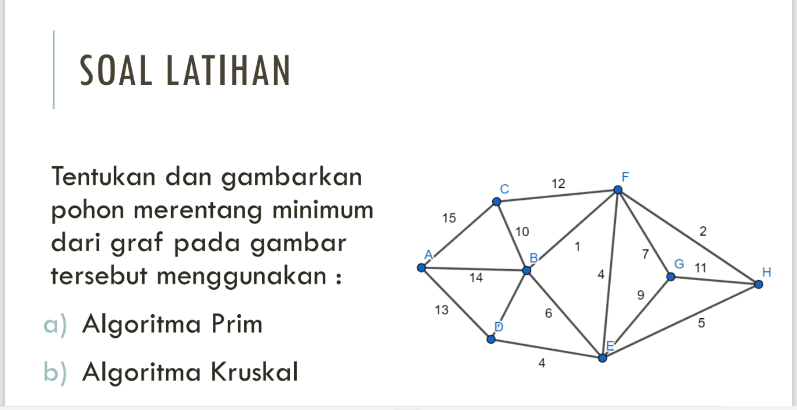

1. Algoritma Prims

|  |  |  |  |
| --- | --- | --- | --- |
| Langkah | Sisi | Bobot | Pohon Rentang |
| 1 | (A, D) | 13 |  |
| 2 | (D, E) | 4 |  |
| 3 | (E, F) | 4 |  |

|  |  |  |  |
| --- | --- | --- | --- |
| 4 | (F, B) | 1 |  |
| 5 | (B, C) | 10 |  |
| 6 | (F, H) | 2 |  |
| 7 | (H, G) | 11 |  |
|  | | | |

Bobot = 13 + 4 + 4 + 1 + 10 + 2 + 11 = 45

1. Algoritma Kruskal

Pengurutan masing-masing sisi secara ascending

|  |  |  |  |  |  |  |  |  |  |  |  |  |  |  |  |
| --- | --- | --- | --- | --- | --- | --- | --- | --- | --- | --- | --- | --- | --- | --- | --- |
| Sisi | (B, F) | (F, H) | (D, E) | (E, F) | (E, H) | (B, E) | (F, G) | (B, D) | (E, G) | (B, C) | (G, H) | (C, F) | (A, D) | (A, B) | (A, C) |
| Bobot | 1 | 2 | 4 | 4 | 5 | 6 | 7 | 8 | 9 | 10 | 11 | 12 | 13 | 14 | 15 |

|  |  |  |  |
| --- | --- | --- | --- |
| Langkah | Sisi | Bobot | Pohon Rentang |
| 1 | (B, F) | 1 |  |
| 2 | (F, H) | 2 |  |

|  |  |  |  |
| --- | --- | --- | --- |
| 3 | (D, E) | 4 |  |
| 4 | (E, F) | 4 |  |
| 5 | (F, G) | 7 |  |
| 6 | (B, C) | 10 |  |
| 7 | (A, D) | 13 |  |
|  | | | |

Bobot = 1 + 2 + 4 + 4 + 7 + 10 + 13 = 41